Project Design Phase-II
Data Flow Diagram & User Stories

Date | 28 June 2026
Team ID
Project Name | Strategic Product Placement Analysis
Maximum Marks | 4 Marks

Data Flow Diagrams:
A Data Flow Diagram (DFD) is a traditional visual representation of the information flows within a system. A neat and clear DFD can depict the right amount of the system requirement graphically. It shows how data enters and leaves the system, what changes the information, and where data is stored.

Example: Strategic Product Placement Analysis System (Simplified)
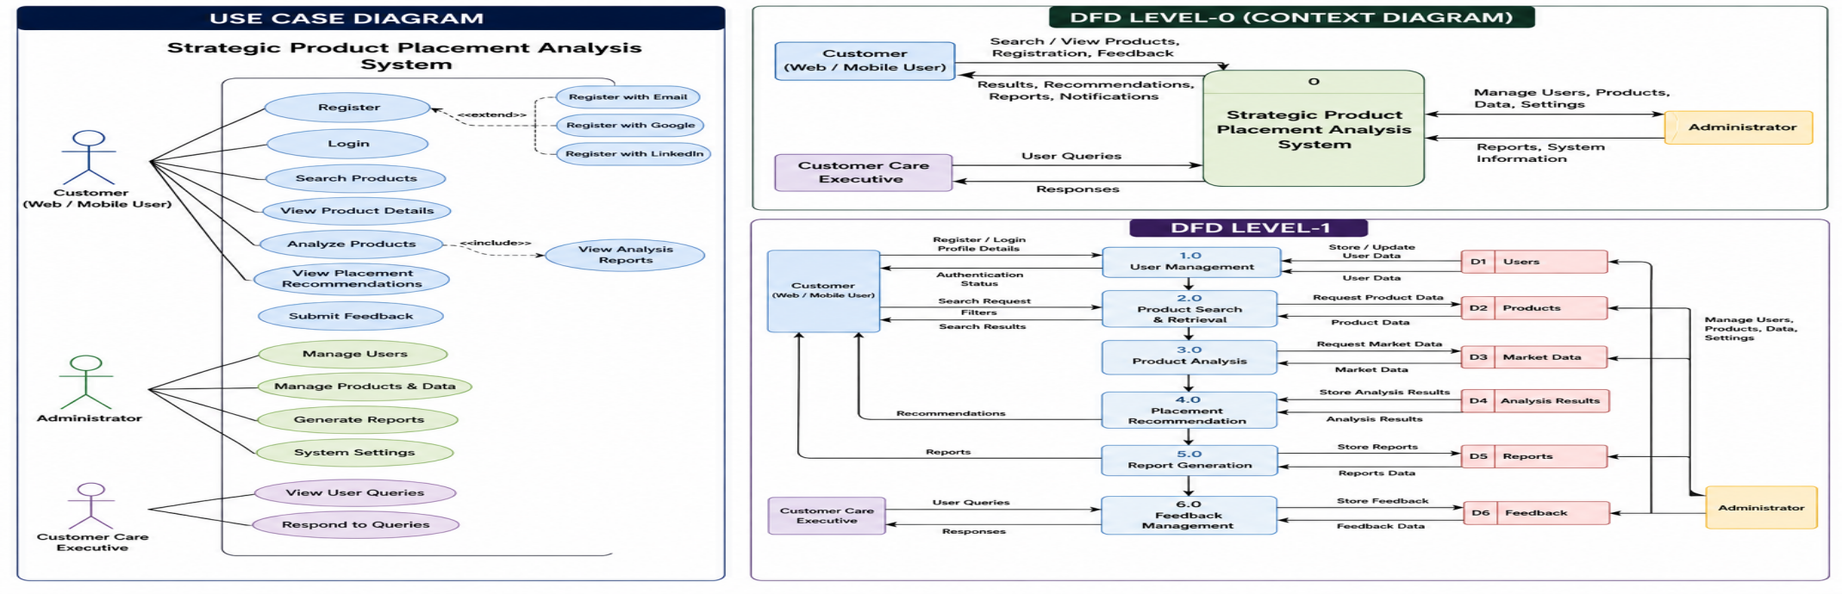
User Stories
Use the below template to list all the user stories for the product.
User Type | Functional Requirement (Epic) | User Story Number | User Story / Task | Acceptance Criteria | Priority | Release
Customer (Mobile User) | Registration | USN-1 | As a user, I can register for the application by entering my email, password, and confirming my password. | I can access my account/dashboard. | High | Sprint-1
 |  | USN-2 | As a user, I will receive a confirmation email once I have registered for the application. | I can receive the confirmation email and click confirm. | High | Sprint-1
 |  | USN-3 | As a user, I can register for the application through Facebook. | I can register and access the dashboard using Facebook login. | Low | Sprint-2
 |  | USN-4 | As a user, I can register for the application through Gmail. | I can register and access the dashboard using Gmail login. | Medium | Sprint-1
 | Login | USN-5 | As a user, I can log into the application by entering my email and password. | I can successfully log in and access the dashboard. | High | Sprint-1
 | Dashboard | USN-6 | As a user, I can view product placement analysis and recommendations on the dashboard. | I can view analysis reports and recommendations successfully. | High | Sprint-2
Customer (Web User) | Product Search | USN-7 | As a web user, I can search and analyze products. | Search results and analysis are displayed correctly. | High | Sprint-2
Customer Care Executive | Feedback Management | USN-8 | As a customer care executive, I can view and respond to user queries. | User queries can be managed successfully. | Medium | Sprint-3
Administrator | User Management | USN-9 | As an administrator, I can manage users and system data. | Users and data can be updated or removed. | High | Sprint-3
Administrator | Report Generation | USN-10 | As an administrator, I can generate analysis reports. | Reports can be generated and downloaded successfully. | High | Sprint-3

